|  |  |
| --- | --- |
| COC_L2_CMYK.jpg | Applying Online for a Board Vacancy |
| Revision Date: 2022-Aug-09 |

# Access the Boards, Commissions and Committees Webpages

Information on the City’s Boards, Commissions and Committees and the online application form is available by visiting www.calgary.ca/boards

# View Board Eligibility Requirements

To view the eligibility requirements for a specific Board, Commission or Committee:

1. Go to the City Clerk’s webpage at www.calgary.ca/boards
2. In the banner, click **Apply Now**. This will take you to the Applications portal.



1. You can view the entire list of “Boards” or select the “Vacancies” Tab to see only the Boards accepting citizen applications.

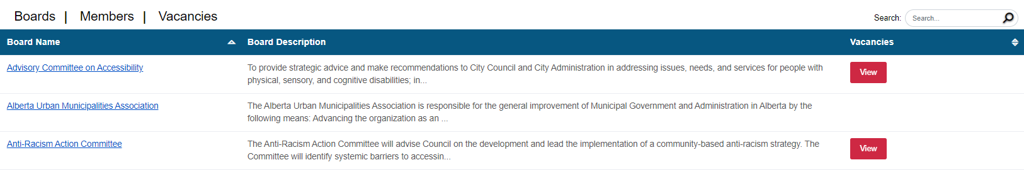

Click on a Board Name (hyperlinked) to access detailed information on its mandate, when meetings are held, eligibility requirements and other information.

Click on “View Vacancies” to see the current openings for a single Board.



Click on “View” to get more information and to access the application form.

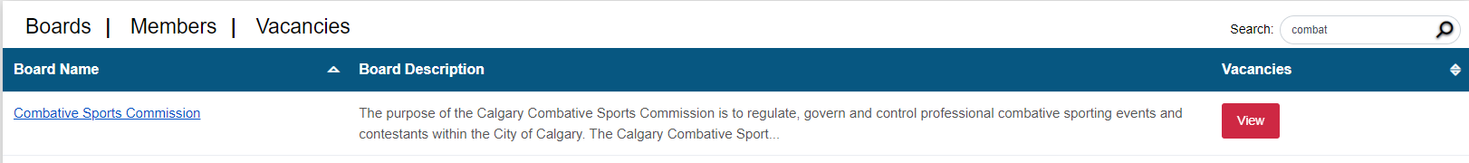

To see the full list of available vacancies, select the “Vacancies” Tab and click on the green arrow  to ave details on the positions(s) and to access the application portal.

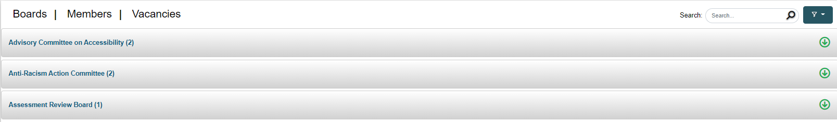

# Apply for a Position

1. Click on the name of the committee you are interested in. You will see the number of positions to fill and the type of position. Click “Apply” next to the position you are eligible to serve.

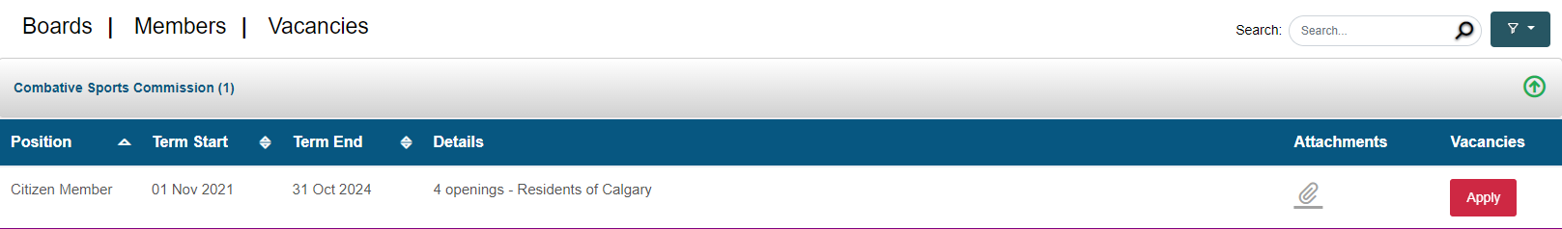

1. An online application will open, fill all the required fields

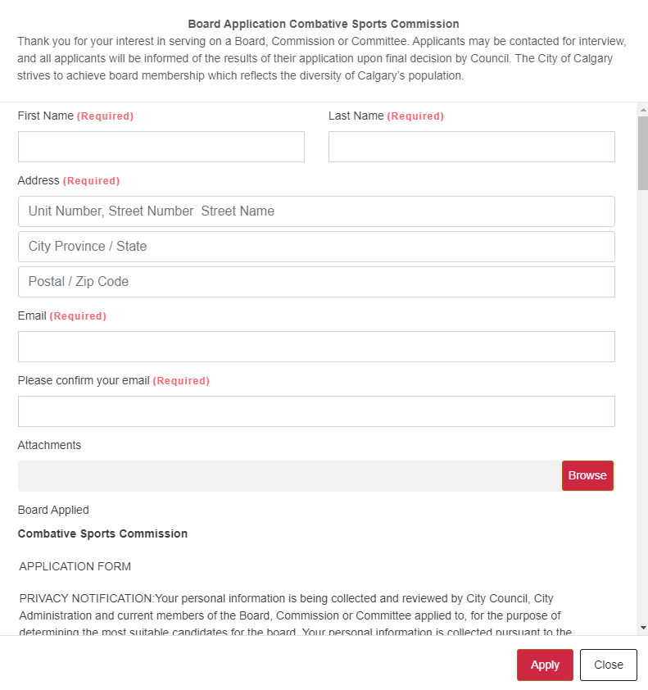

Enter the required submission information

Complete the required fields (Name, Address, Telephone Number, etc.). For your Address, you must type something in all three lines.

Privacy Notification

Personal information is being collected for review by the selection committee for the purpose of determining the most suitable candidates for the board. This information will be retained for one year, after which period, all application and personal information gathered will be destroyed. Acknowledgement is required to move forward with the application.

Eligibility and Skills

Many Boards list conditions which make you eligible to apply. Some Boards require specific skills or experience from volunteers. Check all boxes that apply to you.

Choose between uploading a Resume or manually entering your background and experience

A resume is NOT required in order to apply. Applicants can share information that would normally be contained in their resume using the following fields:

1. Why are you interested in xx Committee?
2. Related education and training
3. Related employment or professional background
4. Community Activity

You also have the option of attaching a Resume (in .pdf format only) to your application. Browse to the location on your device where it is saved in order to attach it. If attaching a resume, you must still enter something in the 4 fields above (example: “see resume”)

Review the voluntary demographic questions

The remaining questions are voluntary. Complete all, some or none. Information provided here is anonymous and is not connected to your application. It aims to help us measure and understand diversity in the City’s public appointments. Any reporting done on demographic information is only reported in aggregate and cannot be traced back to an individual.

Submit application

If you have difficulty submitting, first review all the Required fields and confirm that they have been completed.

If you require further assistance, please contact the City Clerk’s Office at (403) 268-5861 or send an email to [BCCadministration@calgary.ca](mailto:BCCadministration@calgary.ca)